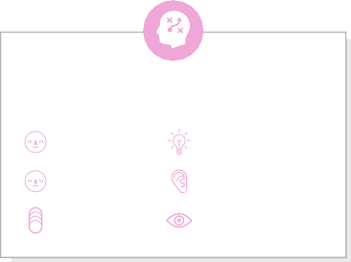

User generated content

Engage with customers

Community involvements

Health and safety measures

Online reviews



Professional

Photography

collabration

Event and specials

Online adversting

Customer testinomials



**1**

**Define your problem statement**

Google My Business Profile

**5 minutes**

**2**

**Brainstorm**

ideas

Google my business profile

**3**

**Group ideas**

Grouping the ideas

**20 minutes**

**4**

**Prioritize**

Prioritized format

**20 minutes**

**Brainstorm**

**& idea prioritization**

Use this template in your own brainstorming sessions so your team can unleash their imagination and start shaping concepts even if you're not sitting in the same room.

**10 minutes** to prepare

**1 hour** to collaborate

**2-8 people** recommended

**PROBLEM**

Google MY business Profile to I'm trying to develop a business profile to promote our Brand on any of the social media of your choice posting the profile directly but by creating a promo link for the business profile

**Key rules of brainstorming**

To run an smooth and productive session

# Vindhiya.L

**Income Potential**

**Improves Creativity**

**Develop Social Interaction**

**Great Community Impact**

# Priyadharshini.k

**Flexibility**

**Job Creation**

**Reputation and Branding**

**Customer Loyalty**

Google my business profile

Local SEO

**Social media content**

Stay in topic.

Defer judgment.

Encourage wild ideas.

Listen to oth**e**

If each of these

fddd

Go for volume. If possible, be visual.

tasks could get done without any difficulty or cost, which would have the most positive impact?

[**Share template feedback**](https://muralco.typeform.com/to/CiqaHVat?typeform-source=app.mural.co)

# Sivanandhini.S

**Tax Benefits**

**Personal Satisfaction**

**Convenience**

Social Experience

# Vinisha.P

**Special Occasions**

**Professional Cooking**

**Time-Saving**

**Exposure to New Foods**

**Feasibility**

Regardless of their importance, which tasks are more feasible than others? (Cost, time, effort, complexity, etc.)

**Template**